Creating a Form
To create a form, follow these simple steps:
- Open up your database and double click on the table name to open it up like this:

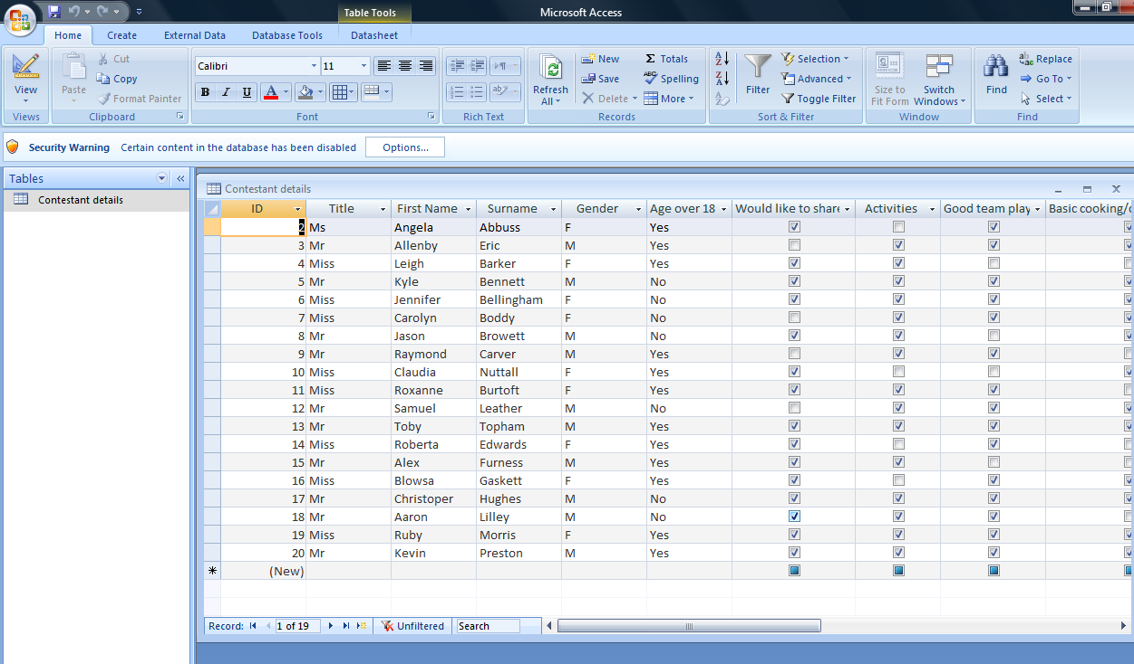

- Select Create and then Form from the top:

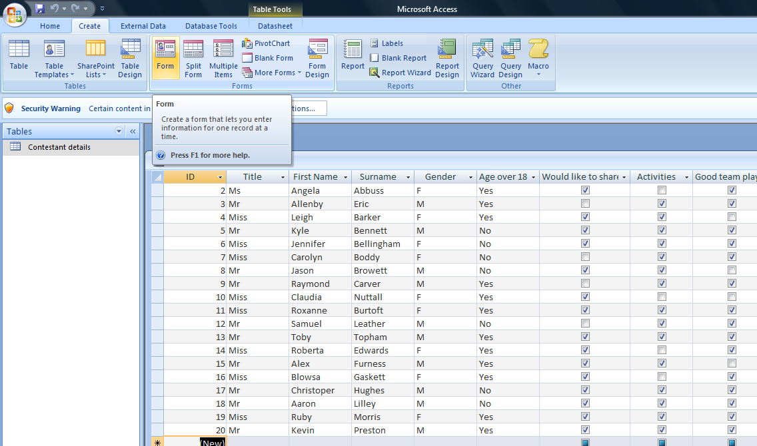
- You are ready to add data to this database:
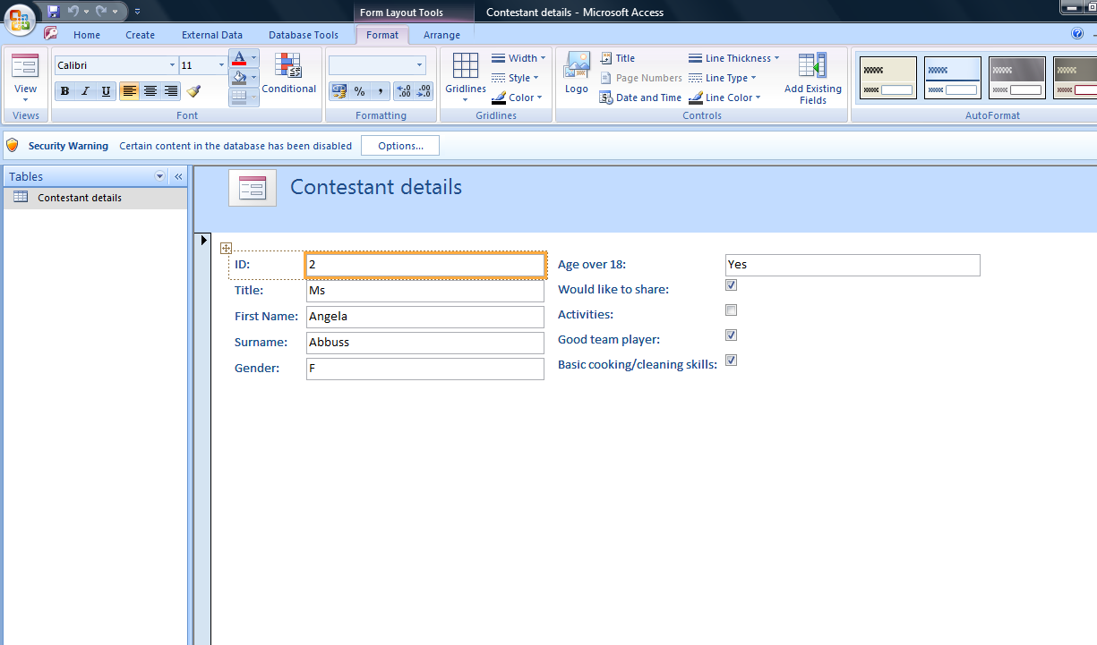
- If you want to add a suitable title and colour, click on the View button and select design view from the drop down menu:
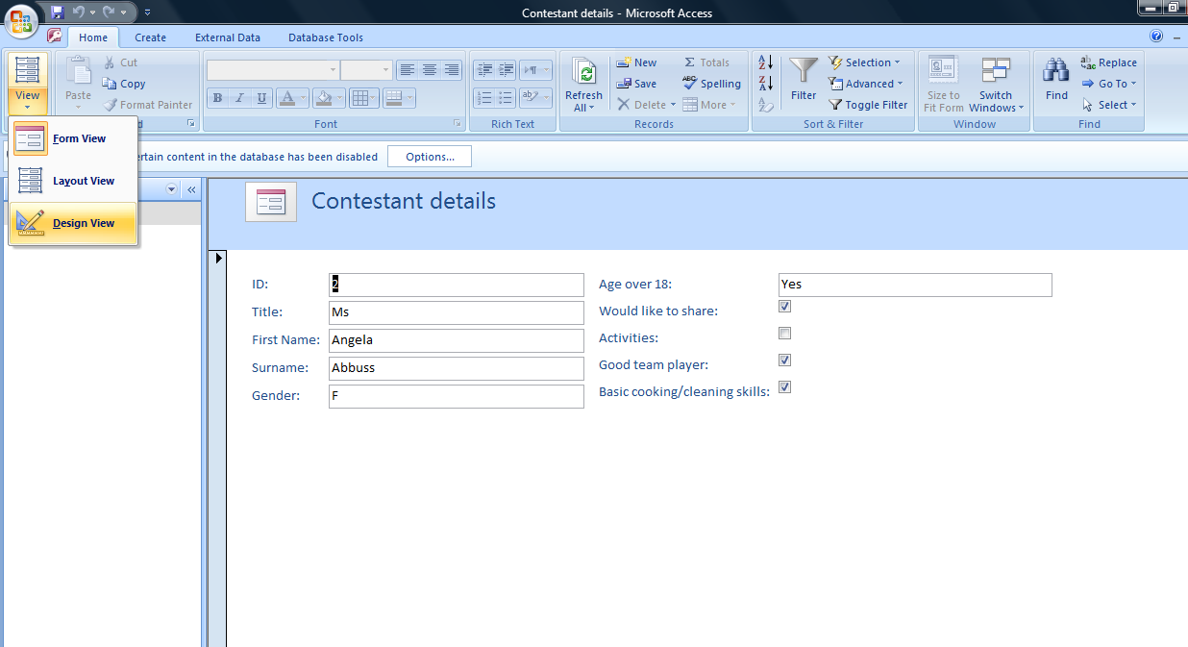

- From the top select the colour and type the text.
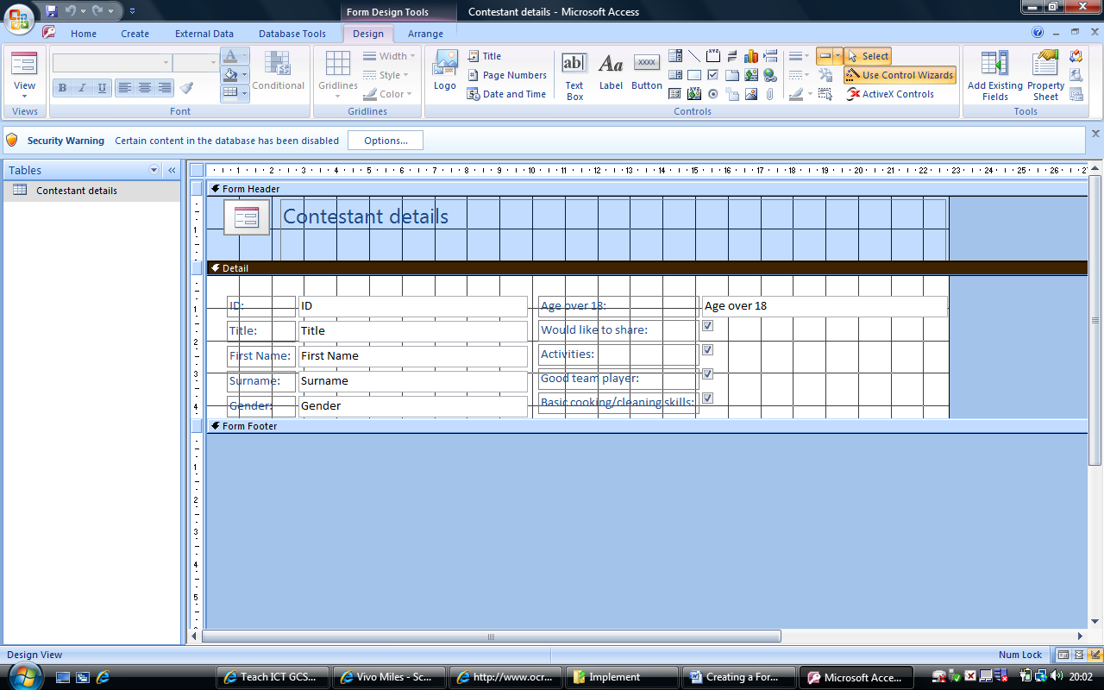

Your task:
Once you are happy with your form, print screen into a word document and explain what you have done and why you have created a form.

