Evidence of Improvements
Improvement 1: Add more images
Before changes were made:

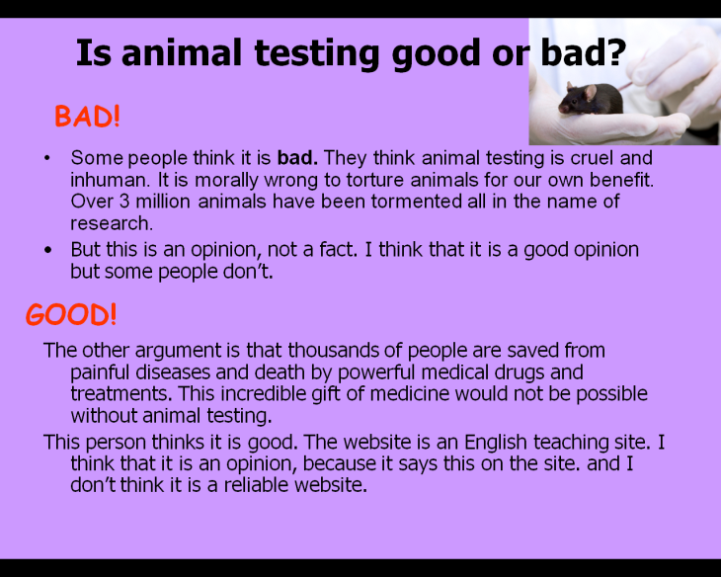

After changes were made:

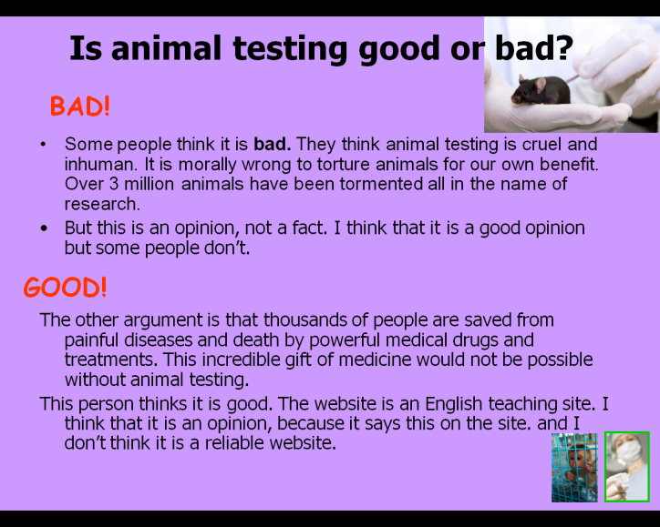
I have added two more images that are suitable for the slide and it makes the presentation look interesting.

