Task: Read the email below and then using a highlighter
highlight all the information required to complete this project.

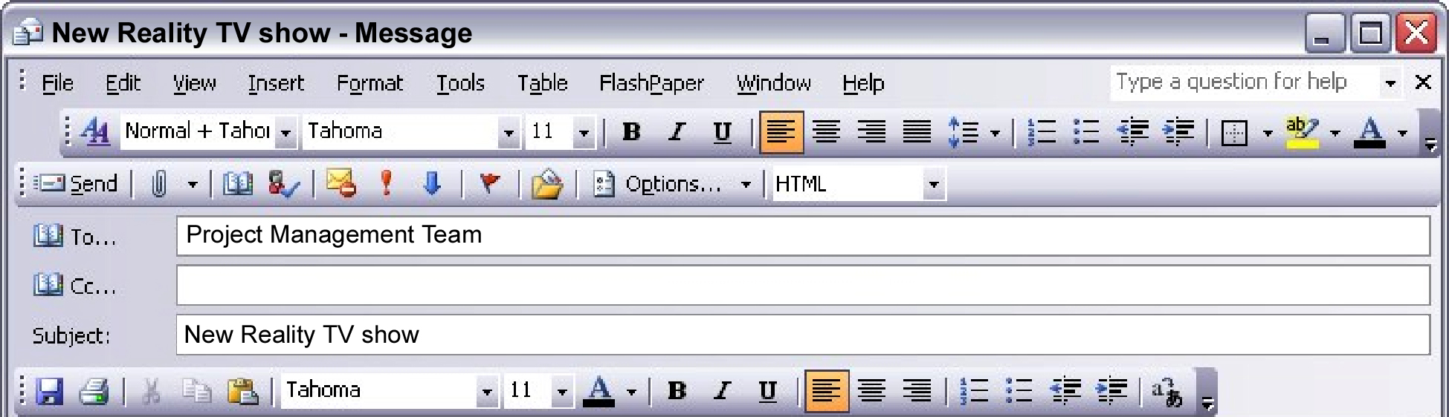

Dear Project Management Team

We have decided upon the name of a new Reality TV show called No Escape. However, we need your help with this project: storing all the data in a suitable format. It’s really important that we create an amazing show and that everything runs smoothly. We must do better this time around!

First of all I will need help in storing the information somewhere safe and in a suitable format so that the information can be used. You will be doing this by creating a database. Secondly you will be asked to create a questionnaire to question potential contestants. You will use Microsoft Word to do this. Once the information is gathered from these questionnaires you will be asked to store this data in a database using a package called Microsoft Access. Once data is entered you will answer some simple questions and FINALLY you will have the chance to evaluate the whole project and see what worked well and what can be improved for next time.

You will need to use the System Lifecycle to help you plan each step of your project.

Good luck and I look forward to hearing from you soon.

Yours,

Mike Real

Executive Producer
Get Real TV Ltd.

