Radio Telescopes

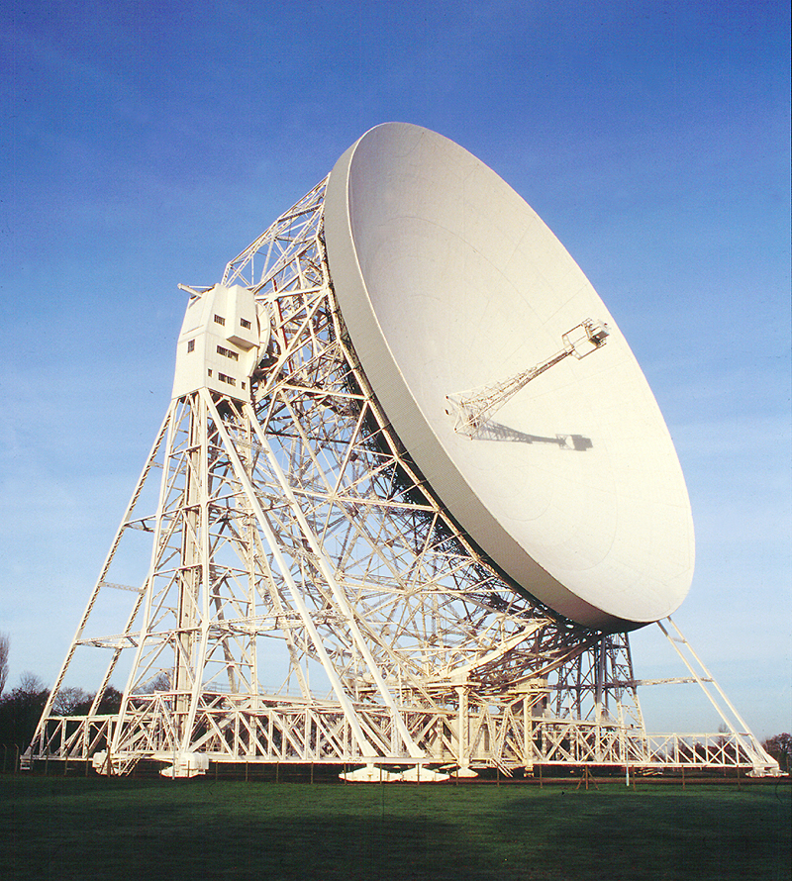
The Lovell 76m radiotelescope at Jodrell Bank is one of two telescopes in the world (the other one is in Puerto Rico) which have begun to conduct the most sensitive and comprehensive search ever undertaken for radio communication signals from Extra-Terrestrial Civilisations beyond our Solar System. Jodrell Bank is a world leader in the development of sensitive receivers. It is this technology along with the large collecting area of what is still the second largest fully steerable radiotelescope in the world that has made the Lovell telescope so attractive to project Phoenix. To give you some idea of what this means, the system on the Lovell telescope could detect a mobile phone from a distance of 220 million miles!
The search being undertaken is a "targeted search" looking at specific objects in the sky. These are obviously where you think that it is most likely that such signals might come from, that is, the home of another civilisation. The search is being carried out during two three-week observing sessions each year and will continue for several years. If an extra-terrestrial signal were detected, it would be one of the most dramatic discoveries ever made.
We can learn many things about our planet and the universe by using telescopes and satellites. A method called remote sounding can tell us about:
- Atmospheric composition
- Temperature
- Cloud structure
- Cloud composition
- Topography
- Surface conditions,
and may also help us to detect new civilisations, stars and black holes.

